**Employee Id:11949**

**Employee Name:Muthuraj**

**UML DIAGRAM:**

**Class diagram:**

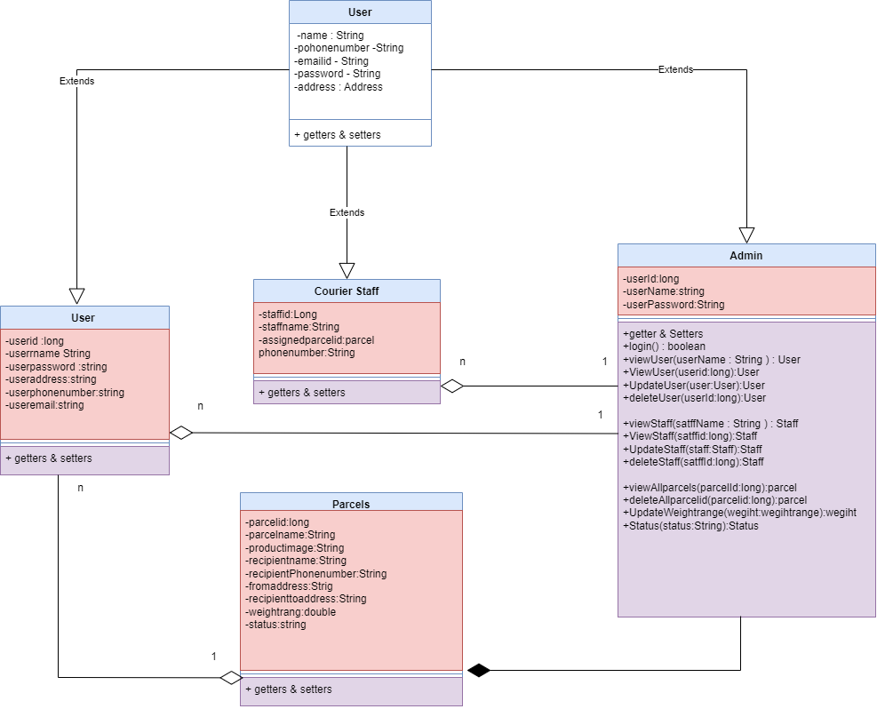

**2.Use Case diagram:**

**1.Actor :Admin:**

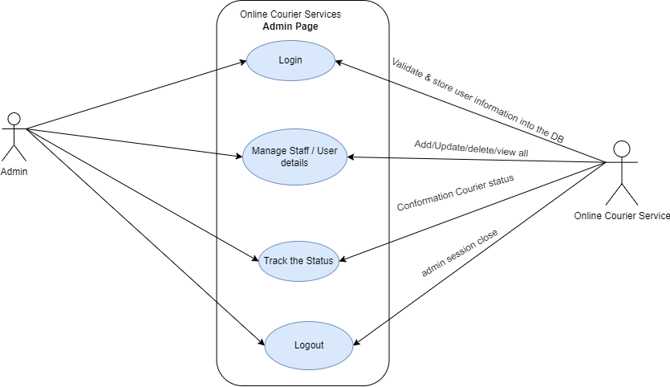

**2.Actor -User :**

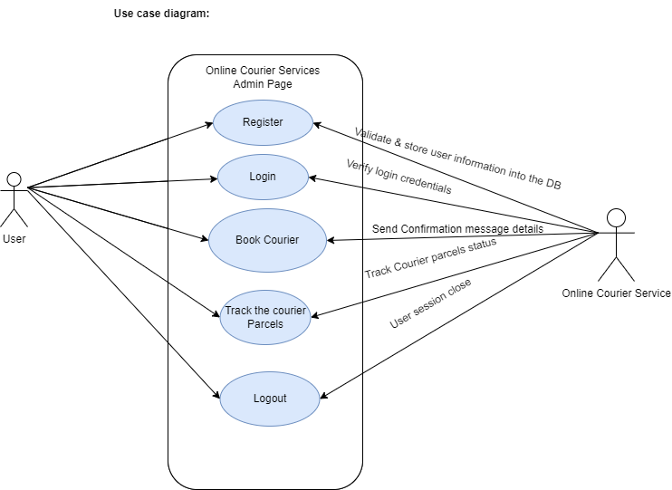

**3.Actor - Staff :**

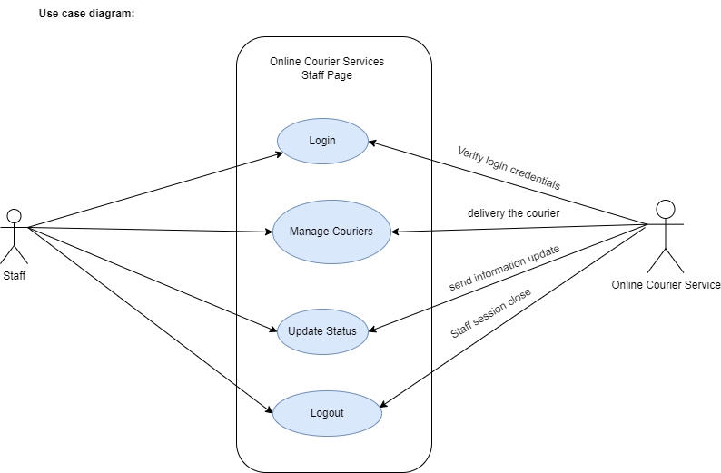

**3.Sequence Diagram:**

**1.Actor - Admin:**

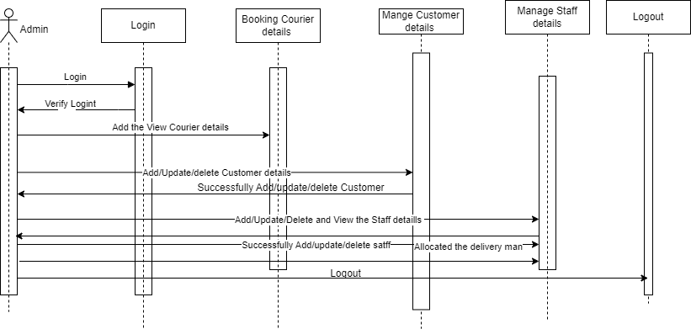

**2.Actor - User:**

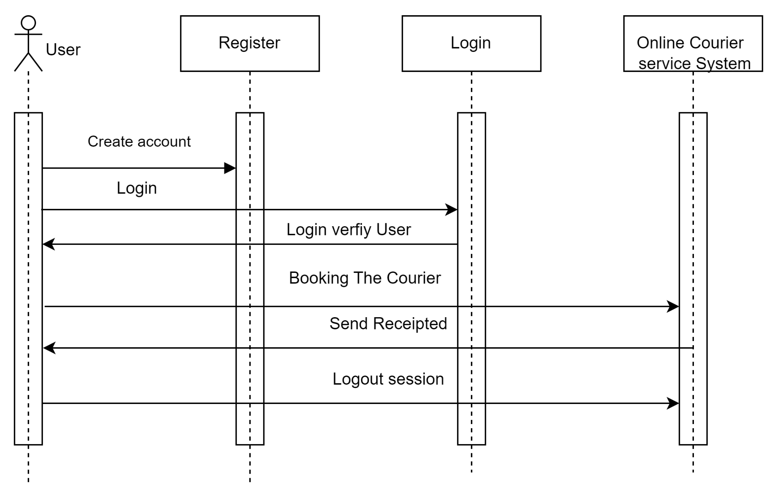

**3.Actor - Staff:**

